

Bhartiya Vidya Bhavan’s

Sardar Patel Institute of Technology, Mumbai-400058

Department of Electronics and Telecommunication Engineering

# IT424: Blockchain Technology and Applications

**Lab-11: To setup Bitcoin clients for various networks.**

**Name:** Shubham Golwal

**Class:** TECOMPS

# UID: 2020300015

**Objective:** To set up Bitcoin clients for various networks.

**Outcomes:** After completing this lab, students will be able to:

1. To explore the Bitcoin ecosystem
2. To install and configure Bitcoin clients
3. To examine various command-line options available in Bitcoin clients.
4. To explore and use APIs are available for Bitcoin programming
5. To evaluate APIs for usage.

# System Requirements:

PC (C2D, 8GB RAM, 100GB HDD space and NIC),Ubuntu Linux 14.04/20.04 Internet connectivity,Python Cryptography and Pycrypto,Nodejs, Truffle,Ganache-cli, solidity,REST API

# Implementation:

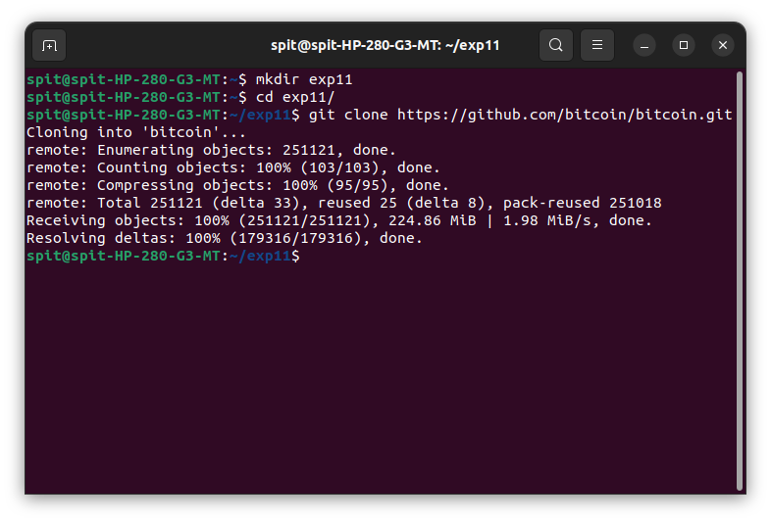git clone <https://github.com/bitcoin/bitcoin.git>

Fig 1: Installing bitcoin client and cloning the bitcoin repository

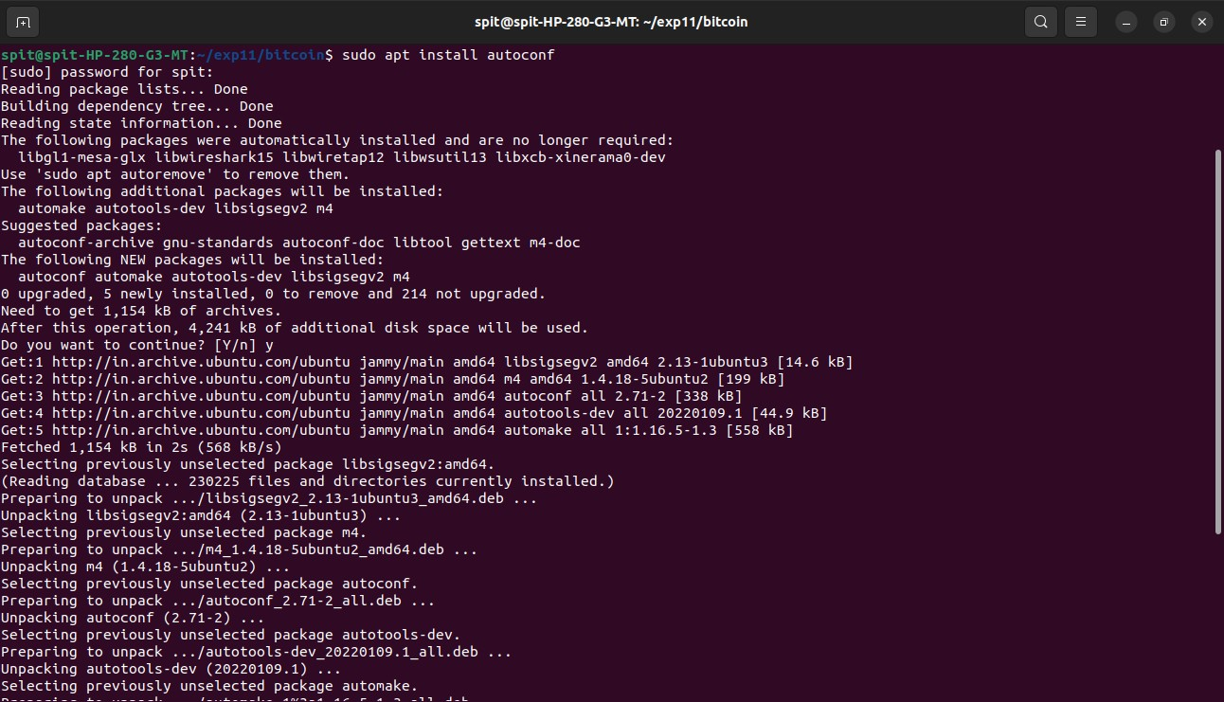

Fig 2: Install the required package autoconf

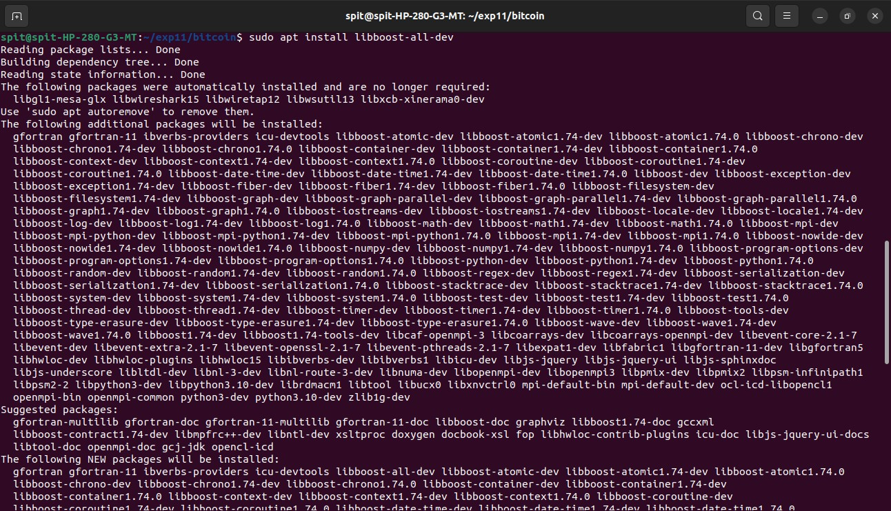

Fig 3: Install the required package libboost

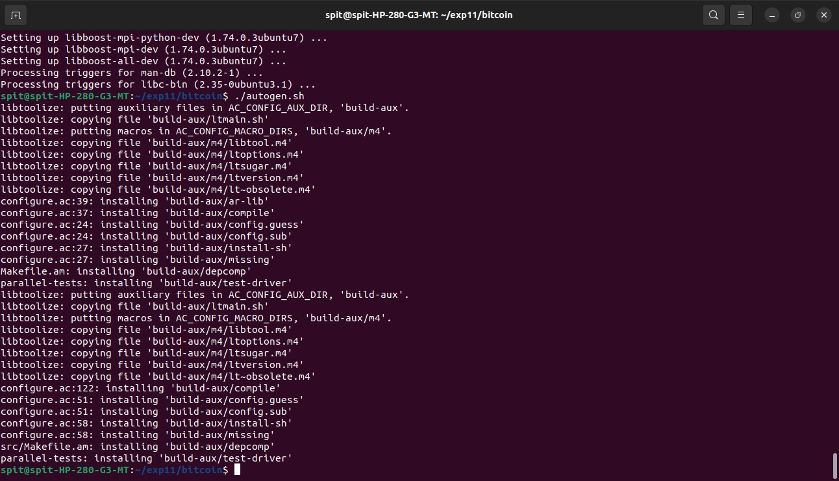

Fig 4: Generate configuration scripts by running autoconf.sh

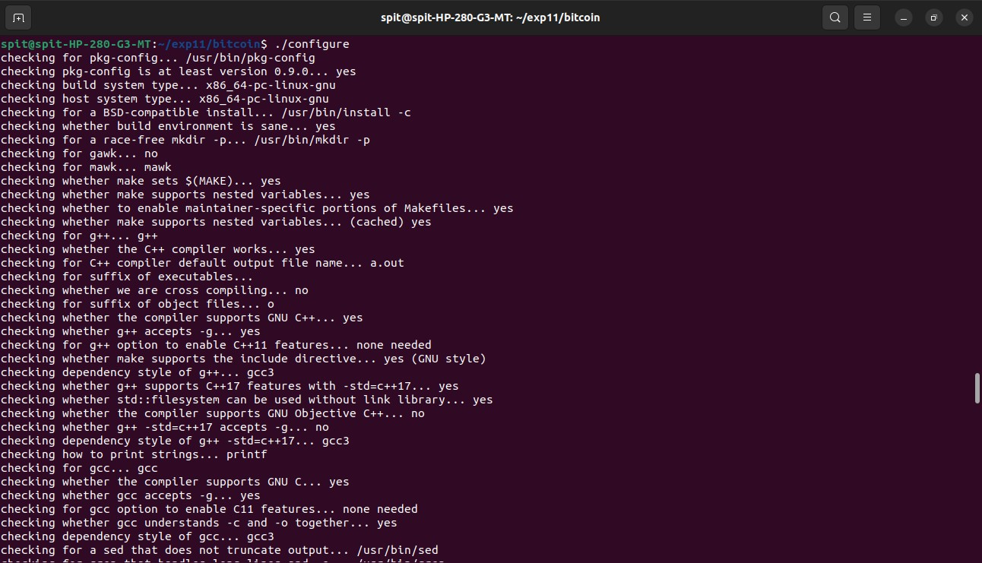

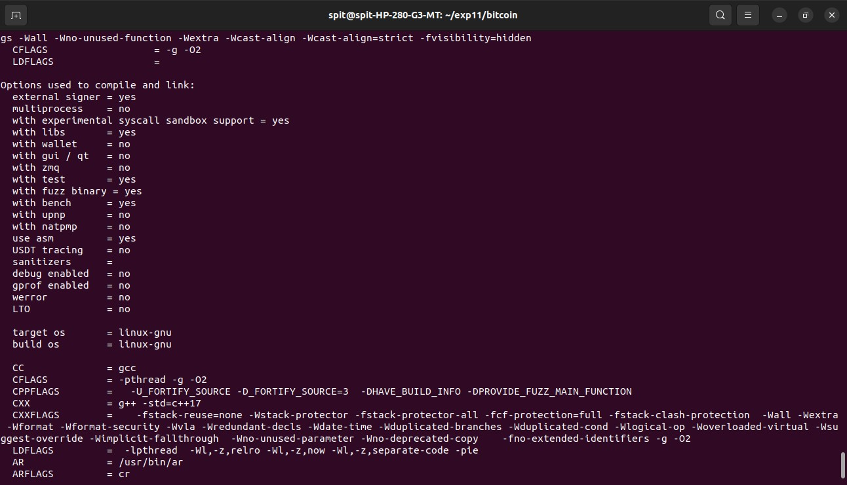

Fig 5: Configure script for setting Bitcoin in our local system.

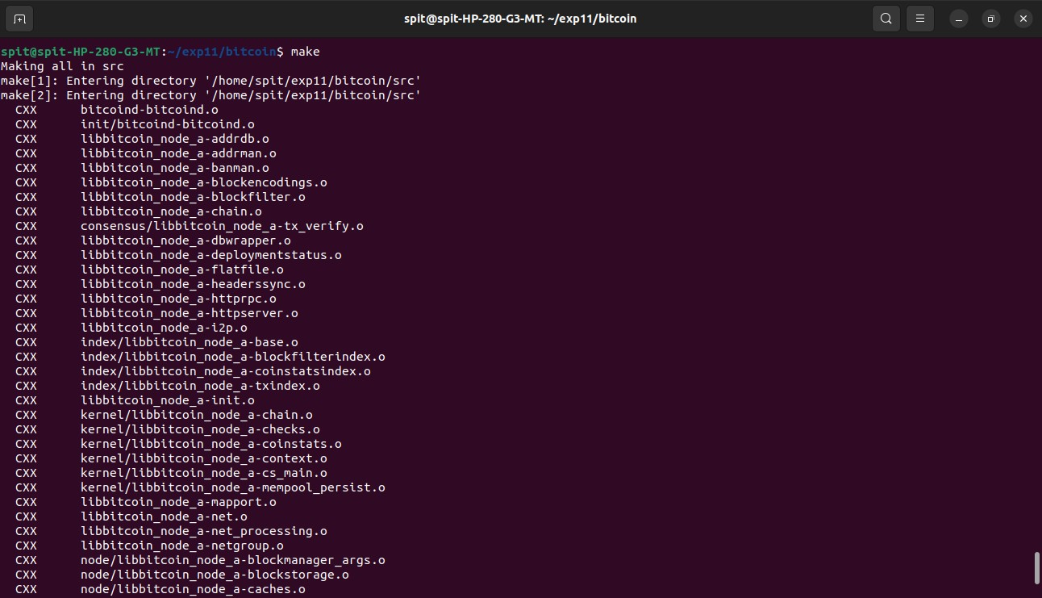

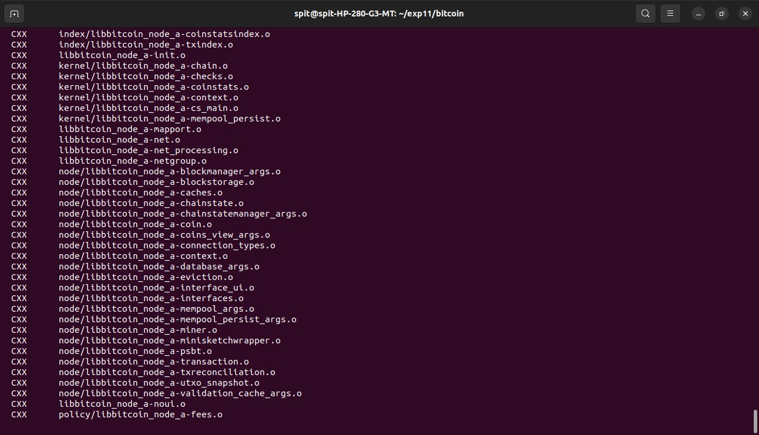

Fig 6: Code getting compiled using make command

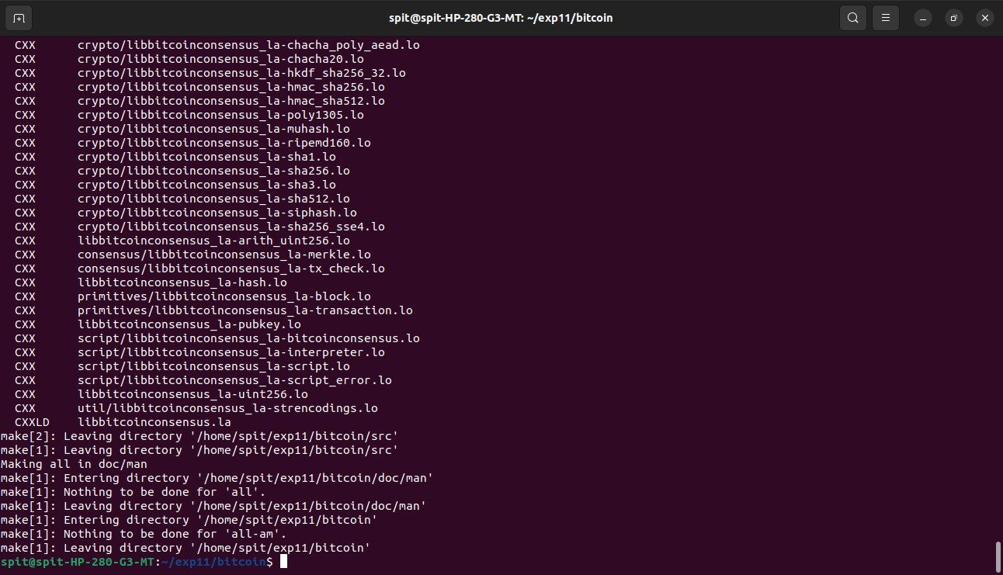

Fig 7: Entire directory got compiled after around 30 mins

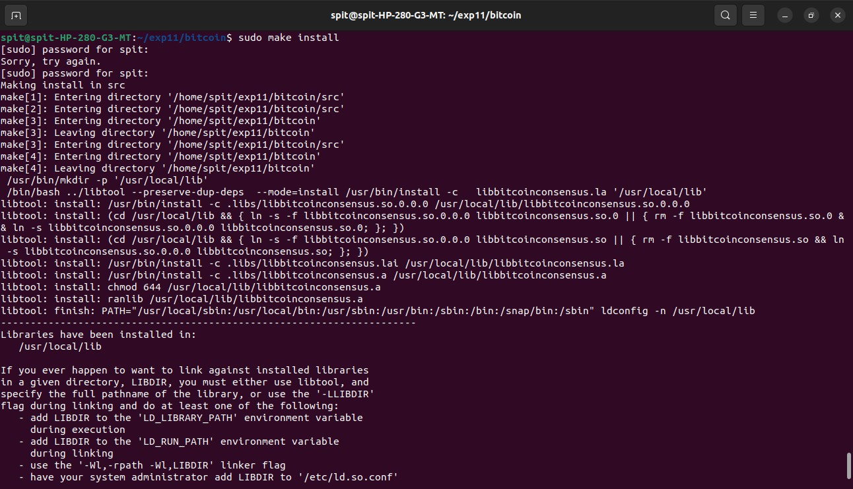

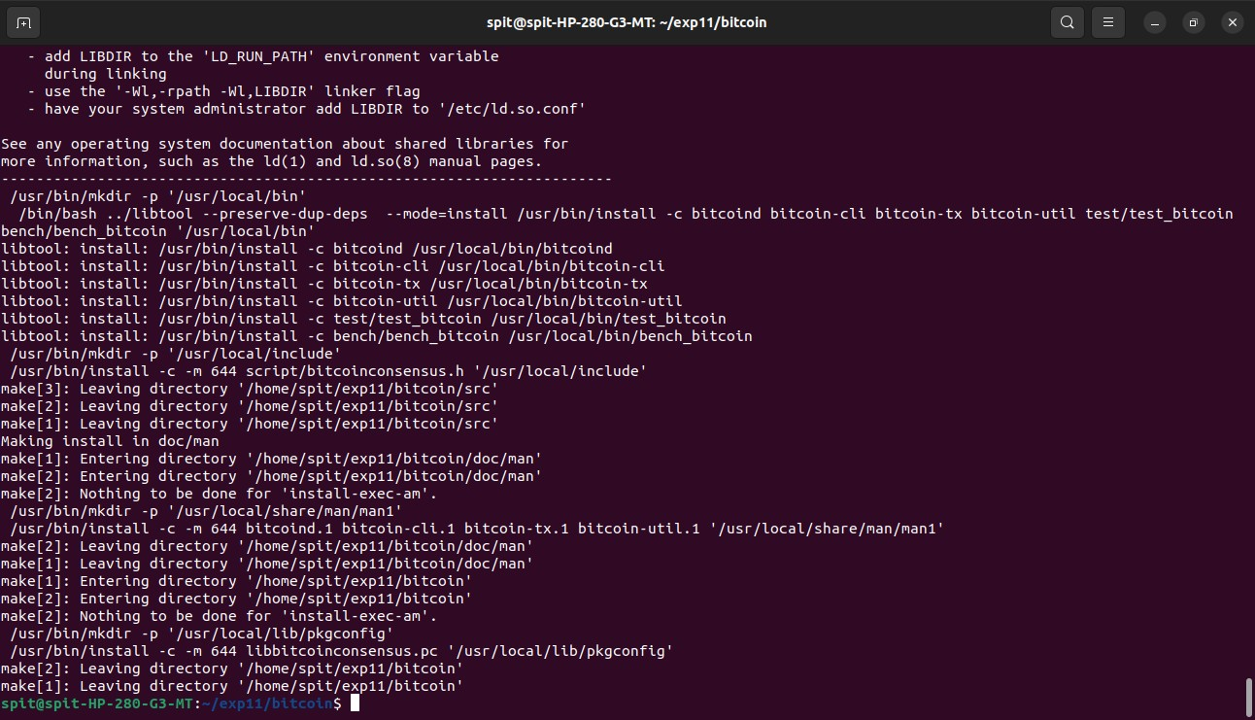

Fig 8: Installing compiled code using make install command

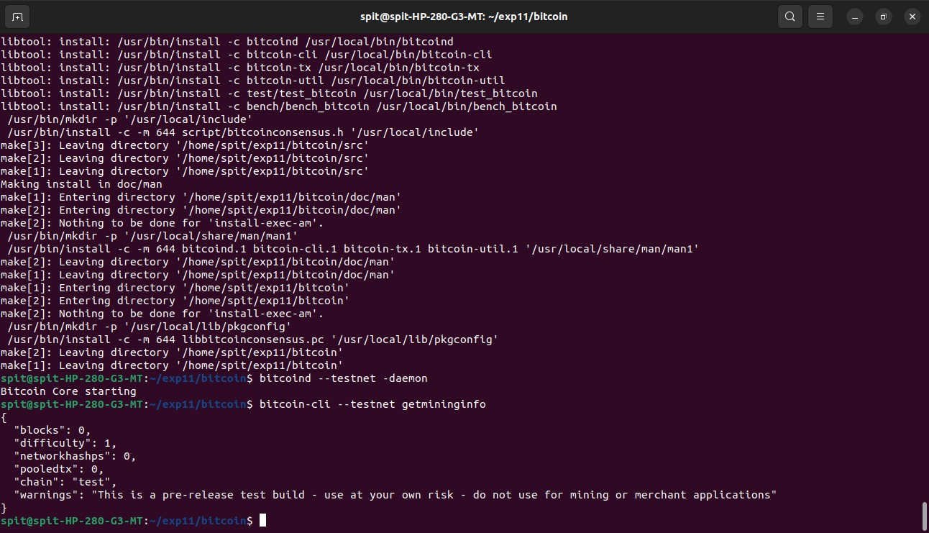

Fig 9: Running Testnet daemon and checking the mining information

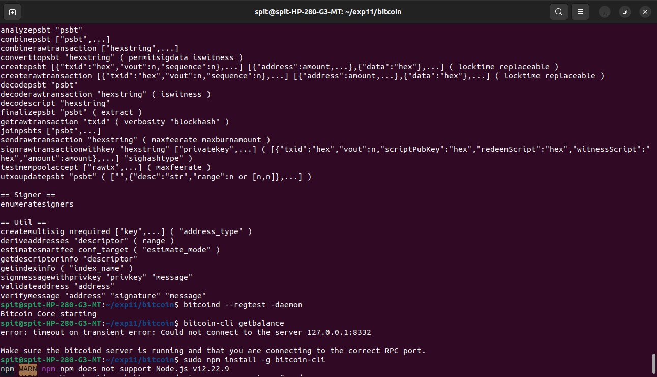

Fig 10: Running bitcoin daemon in regtest mode but function not getting recognized as bitcoin.conf not getting set up correctly.

**Conclusion:**

# I was able to clone the Bitcoin repository and install all the necessary packages on my system. After running the shell script and configuring the system, I used the make command to build and compile the entire package, which took around 30 minutes. I then utilized the testnet daemon to examine the mining information. However, I was unable to progress further as a verified Bitcoin wallet is required to conduct transactions.

# References:

1. https://pypi.python.org/pypi/pycrypto
2. [https://www.tutorialspoint.com/cryptography/](http://www.tutorialspoint.com/cryptography/)